Name of Organization:
Contact Person:
Telephone: |  | Email:
Address:
Nature of Activity:

Is activity for school-based children? |  | Yes |  |  | No
Are you a non-profit organization? |  | Yes |  | No
Ages of participants: |  |  | Number of Participants:
Is a fee charged for involvement in this activity? |  | Yes | Amount of fee:
 |  | No

Participant fee is designed to cover the following expenses:

Rationale for application to have community use fees waived or reduced:

Please note: Waiver or reduction of fee does not preclude charges related to excess custodial services and/or charges for use of supplies as outlined in the Rainy River District School Board policies and procedures. Any application for waiver of direct costs to the Board must be made, in writing, directly to the Community Outreach Officer.

Group Classification:

User Group |  | Rates
Group A | All events held by the school and Board, such as extra-curricular activities, Open Houses, school council meetings, etc. | No Fee
Group B | Not-for-profit youth-related groups, for example, Boy Scouts, Girl Guides, church youth groups, and youth sport and recreation organizations (including those that are members or affiliates of provincial sports or accredited organizations), with or without charitable organization status. | Subsidized
Group C | Not-for-profit adult groups and functions organized by individuals/organizations who may have an admission charge, a participation cost or fee, for example, local service clubs, community health associations, senior groups. | Subsidized
Group D | For profit, for example, functions organized by industry/businesses for profit-making purposes, (e.g., public concerts, trade shows, dance schools, for profit youth activities). | Full Fees

***Reciprocal/joint use agreement users will be governed by their own agreement.***

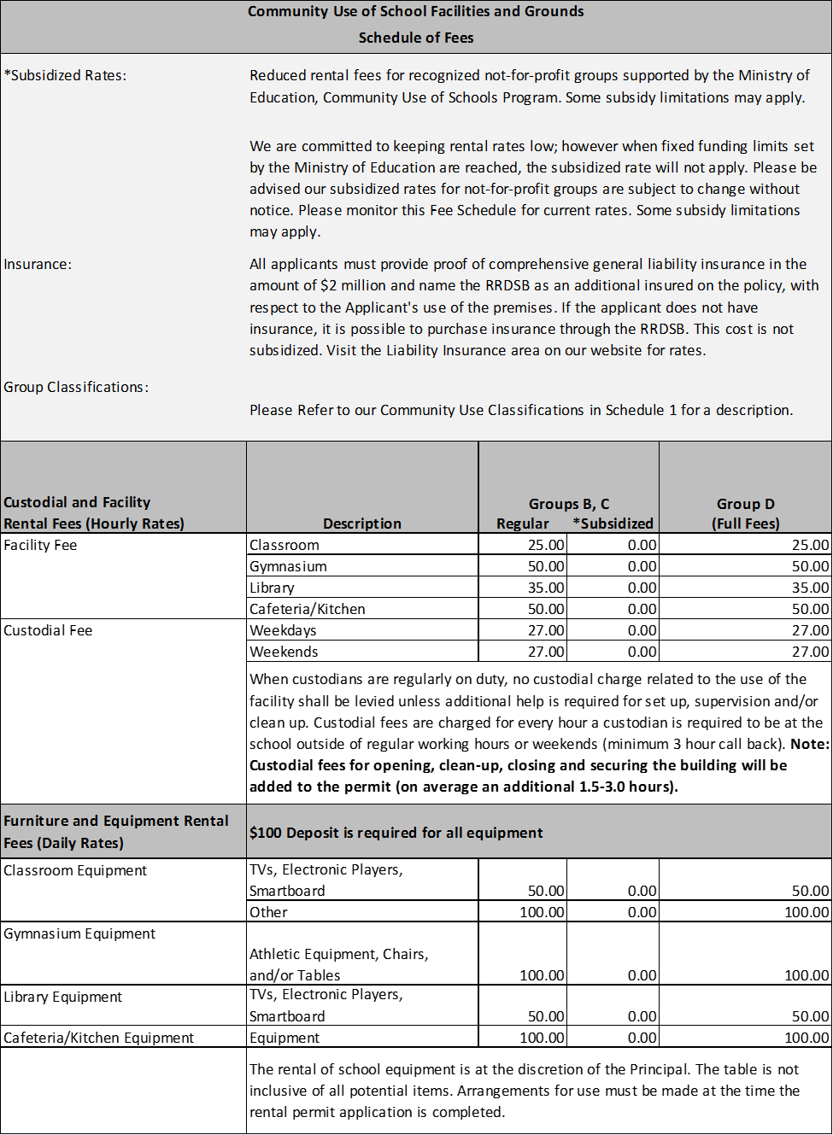

Detailed Description of Applicant’s User Group:

FOR OFFICE USE ONLY
GROUP DESIGNATION: D
SCHEDULE ID: ____________
Approved
Denied | Reason:

Community Outreach Officer |  | Date
Superintendent of Business |  | Date

